1) Write a select command that produces the order

number, amount, and date for all rows in the Orders

table.

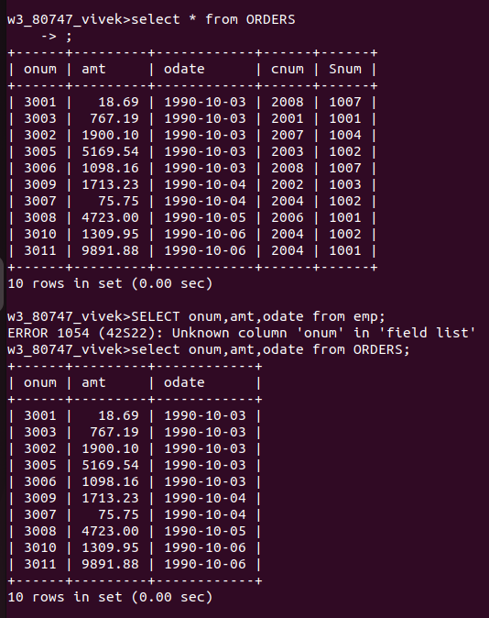

2.Write a query that produces all rows from the Customers table for which the salesperson’s number is 1001.

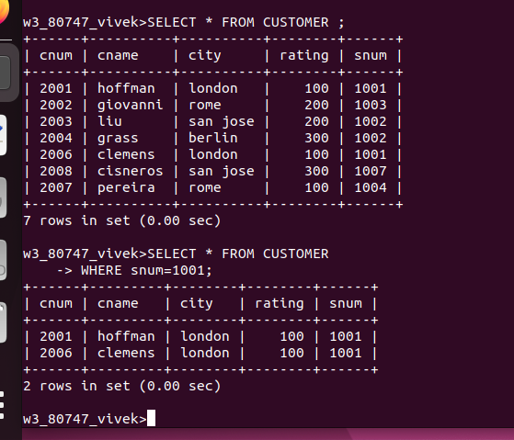

3) Write a query that displays the Salespeople table with the columns in the following order:

city, sname, snum, comm.

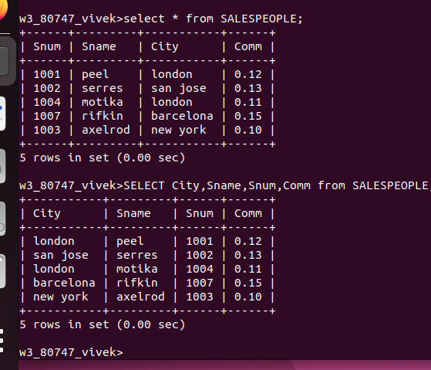

4) Write a select command that produces the rating followed by the name of each customer in

San Jose.

